**CHAPTER TWO**

**Description of the existing system**

**Introduction of the existing system**

Library is regarded as the brain of any institutes, of course many institute understand the importance of the library to the growth of the institute and their esteem users which we categorically call the students.A library management system is an enterprise resource planning system for a library, used to track items owned, orders made, and users who have borrowed.

The Library Management System is a Library Management software for monitoring and controlling the transactions in a library .Library Management System supports the general requirement of the library such as the acquisition, cataloging ,circulation and other sections.

Before the advent of computer in modern age there are different methods of keeping records in the library. Records are kept in the library on shelves and each shelf are labelled in an alphabetical or numerical order, in which the categories of books available are arranged on different position on the shelves and as well are recorded on the library manuscript and when any book is to be referenced the manuscript is being referred to, to know the position of such required book by the person that requested for the book.

After the invention of computer different researchers have carried out various approach on an automated library management system in which this project is as well all about. since the library management system for Ethiopia now days with the existing system working process has no speed and are not using it.

A library management system usually comprises a relational database, software to interact with that database, and two graphical user interfaces(one for users, one for staff). Most integrated library systems, separate software functions into discrete programs called modules,each of them integrated with a unified interface. Examples of modules might include:

i.**Acquisitions** (ordering, receiving, and invoicing materials)

ii.**Cataloging** (classifying and indexing materials)

iii.**Circulation** (lending materials to patrons and receiving them back)

**USER OF THE EXISTING SYSTEM**

1.**STAFF**:someone who control the overall activities of the user system.

**Duties of STAFF**:-

* Arrange the schedule of the user according to the system
* Register the new user
* Accepts users command

2.**USER(CLIENT**):someone who borrows the books.

**Duties of USER**:-

* Borrow the books according to the system
* Returning the book according to the due date.
* Keep the books in safe manner

**Major Functions of The existing System**

In the existing system major functions are done manually , the major functions in the existing system are as the following:-

* **Assign Books**:- in-order to use the books that exist in the library the books should be found in sequential manner. Means they have to be assigned in proper collection in-terms of their content.
* **Generate a Borrower’s card**:- this is a small paper used to write the main description about a book. Every book must have this paper, because this paper will attach with the ID of the user during borrowing.we can take the following as a sample

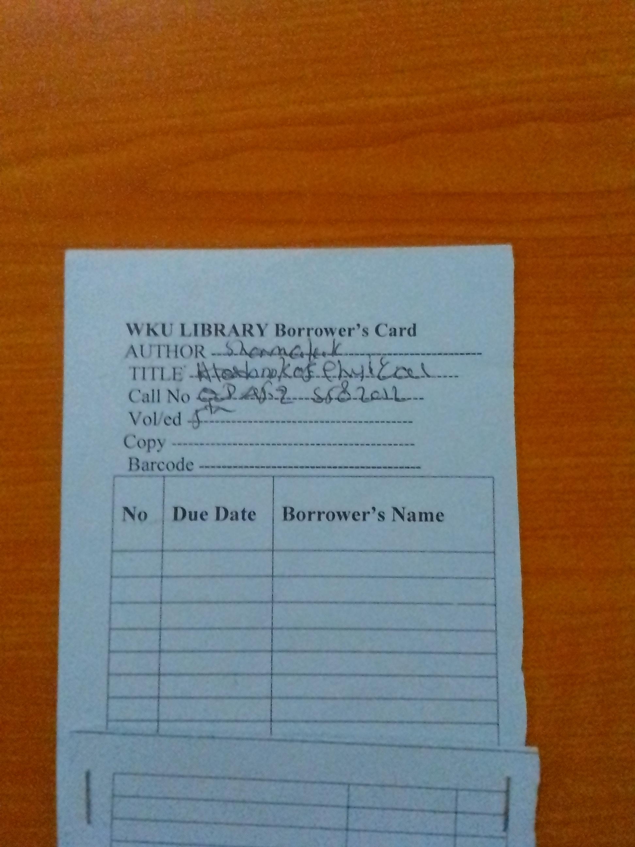

**Drawbacks of the existing system**

* **Time consumption:-** whenever the user wants an access from the library they should be there physically. For example , if a person wants to know as the book he/she wants is exist or not they have to go there and check it, assume if the book do not exist and now calculate the time!!!
* **Unable to take away a book:-** if a person wants to take a book and use it where ever he/she likes it is not possible.
* **Unable to get hard copy resources in IT rooms:-** if a person takes his/her PC to get E-library system, they have no permeation to get books from library.

**Security issues:-** there is a security problem mainly in digital library’s. means , if a person have some issues like make a phone call, taking air or drink coffee they can not do this without taking their computer with them. Unless, maybe they won’t get it on the place, anyone can take it .